Lab 1

- Create a new session in your LLM of choice and ask all assignment-related questions in that session only. You will be required to export and submit your session along with your notebook.
- Follow the instructions on Canvas to create a Databricks account (use your personal email to avoid access restrictions). Paste a screenshot of the workspace to confirm account creation.
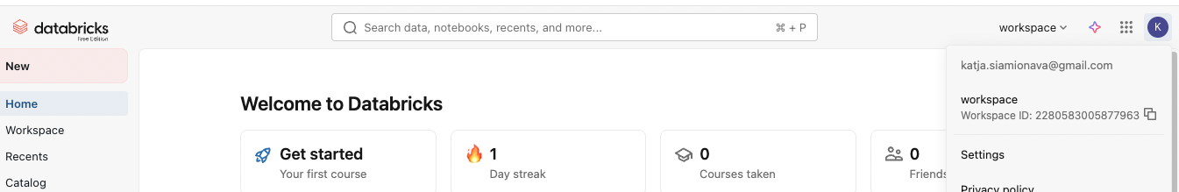
- In the Workspace tab, click on create folder. Create CIS515 folder to store codes related to this course. 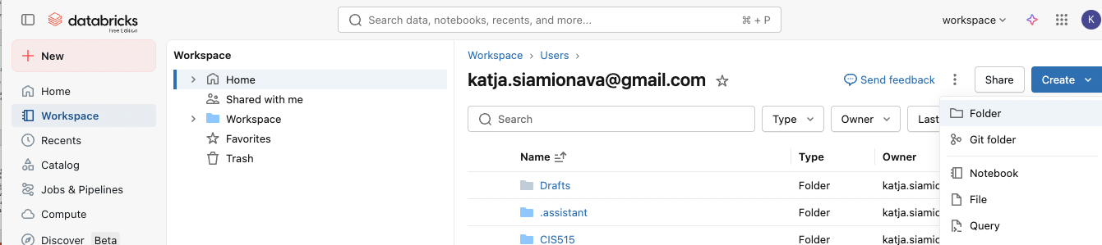
- Within the folder, click three vertical dots and select Import to import the starter notebook.

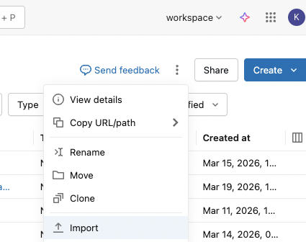
- Once on Databricks, go to Data Ingestion and upload the salaries.csv file posted on Canvas (Week 1 module).
Step1
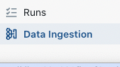
Step2 Select files to a volume
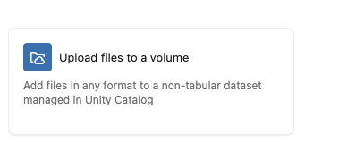
Step3 Drag salaries.csv in the upload box.
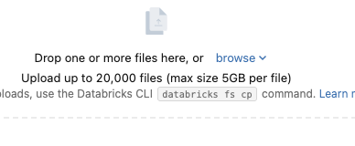
Step4 create a new volume
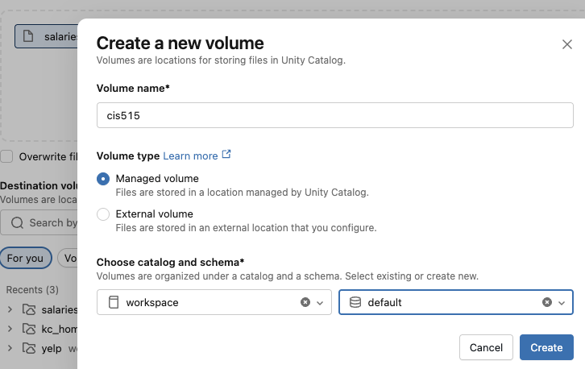
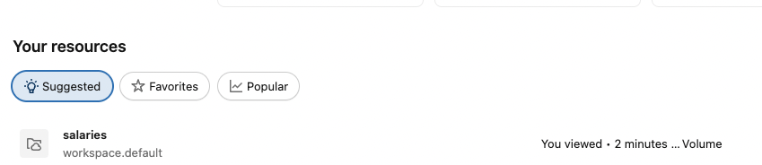
Step 5 Upload the file and copy the file path. You will need to update the path in the starter notebook.
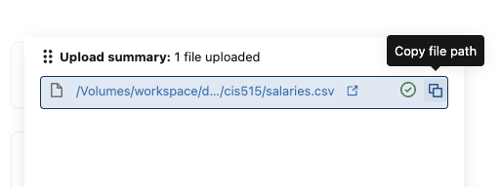

- Load the NN MLflow Demo starter notebook from Canvas.
- Add code following the instructions where it is missing.
- Add a screenshot of the experiment visualizations. Go to experiments. Select models to compare and run comparison. You will be able to create several visualizations like the xample. Your user id should be visible on a screenshot.

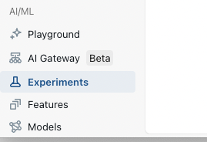
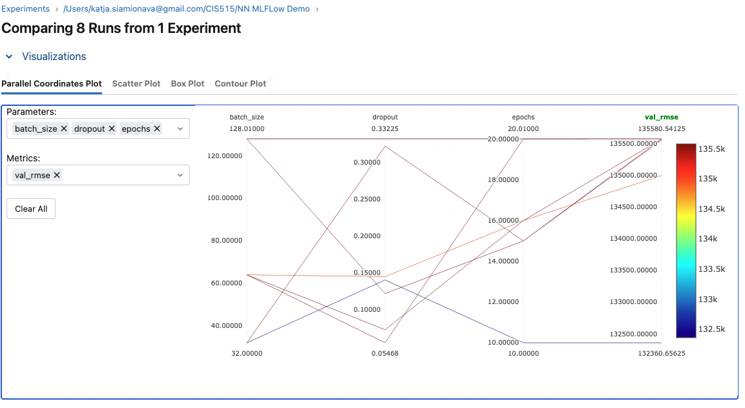
- Answer the reflective questions in the final notebook cell.
- Explore Artifacts, model objects. Go to Catalog and find your models:
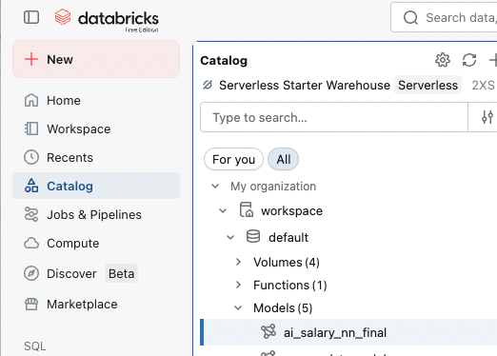
Click on the model to see available versions and linked aliases
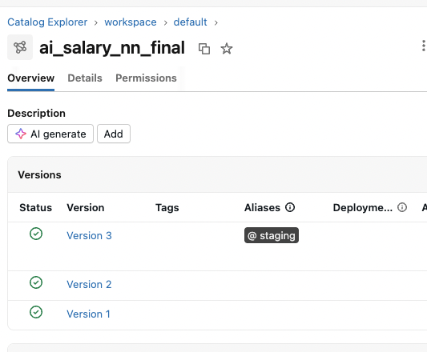
For each version, examine Lineage, Artifacts, Traces. Examine what environment, data and other artifacts are saved for the model.
